 



TIJUANA INSTITUTE OF TECHNOLOGY

## ACADEMIC SUBDIRECTORATE

DEPARTMENT OF SYSTEMS AND COMPUTING COMPUTER SYSTEMS ENGINEERING

SEMESTER FEBRUARY- JULY 2022

## SUBJECT

BDD-1703SC9C Data Mining

Activity

#1

# Professor

MC JOSE CHRISTIAN ROMERO HERNANDEZ

# Student

17212327 -Aldarete Delgado Angel Esteban 17210659 - Villegas Carmona Damaris

Lab #1

Prove the law of large numbers for N normally distributed random numbers with mean = 0, std = 1:

Create an R script that counts how many of these numbers lie between

-1 and 1 and divide by the total amount of N

You know that E(X) = 68.2%

Verify that Mean(Xn)->E(X) while re-executing your script while increasing N

Hint:

1. Initialize the sample size
2. Initialize counter
3. loop for(i in rnorm(size))
4. Check if the iterated variable falls
5. Increase the counter if the condition is true
6. return a result <- counter / N

## Steps:

**1.-** Start creating the variable that will hold the maximum value that we assign to it, in this case it would be 1000000.

**2.-** The counter is initialized to 0.

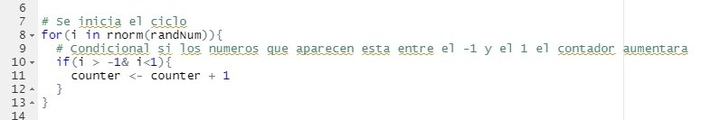**3.-** A cycle is developed, in order to be able to generate the random numbers of the function.

## Code

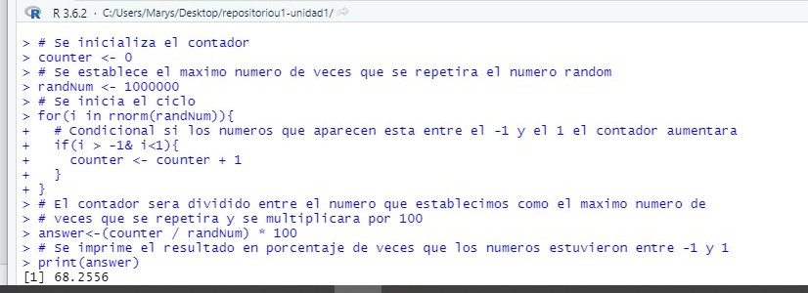**Evidence**